Motion and Force in a Gravitational Field

Home Assignment Torque and Equilibrium
Name: ANSWERS (30 marks total)

- Cars are much more stable than motorcycles. Using your understanding of stability and torque, explain why. (3 marks)

A car has a large base and a low centre of mass. A motorcycle also has a similar centre of mass but a much smaller base. Stability comes when the centre of mass is within the base of the object. [1 mark]

With a car it is much harder to provide a torque which can move the centre of mass outside the base of the car. [1 mark]

With a motorcycle, only a small force can move the centre of mass outside the base of the wheels and then the weight of the motorcycle will provide a torque and the motorcycle will fall over. [1 mark]

- A yard broom has a wide brush and a 1.90 m long handle. The brush has a mass of 3.85 kg and the handle a mass of 1.30 kg. The easiest way to pick the broom up is at its centre of mass. Calculate this position along the broom handle. (3 marks)

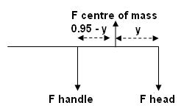
take moments about centre of mass
ΣCM = ΣACM
37.73 x y = 12.74 x (0.95 – y) [1 mark]
37.73y = 12.103 – 12.74y
50.47y = 12.103
y = 0.2398
y = 0.240 m

so hold the handle 24 cm from head. [1 mark]
F handle = 1.30 x 9.8
= 12.74 N
F head = 3.85 x 9.8
= 37.73 N
[1 mark]

- David is trying to unscrew a small nut using a spanner. David can exert a force of 592 N at the end of the spanner which is 305 mm from the nut. What maximum torque can be exerted by David to unscrew the nut. (2 marks)

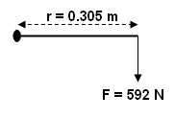
τ = Fr⊥
= 0.305 x 592 [1 mark]
= 180.56

τ = 181 Nm [1 mark]

- Using a small ‘x’, indicate the approximate location of the centre of mass of the following objects. You should show any construction lines used to help you find the centre of mass. (2 marks)
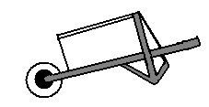
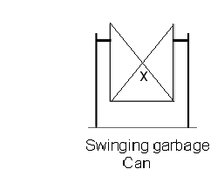
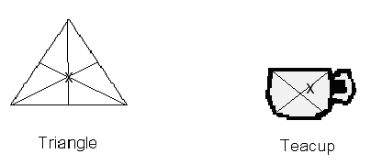

- A fully laden wheelbarrow has a total mass of 97.0 kg. The centre of mass is located one third the distance between the axle and the end of the handle. Calculate the minimum force required to lift the wheelbarrow from a horizontal position. (2 marks)
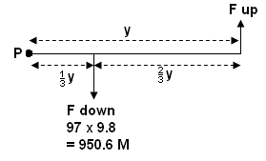
Take moments about P
ΣCM = ΣACM
950.6 x y = F x y [1 mark]
cancel ‘y’
950.6 x  = F
F = 316.87

minimum force = 317 N [1 mark]

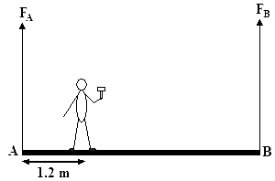

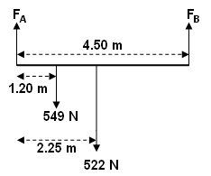
- A uniform plank, AB, of length 4.50 m and weight 522 N is suspended by a vertical rope at each end. Sarah of weight 549 N, stands in the position shown, 1.20 m from the end A. Calculate the tension in each of the ropes. (3 marks)

Take moments about F_{A}
ΣCM = ΣACM
(549 x 1.20) + (522 x 2.25) = F_{B} x 4.50 [1 mark]
658.8 + 1174.5 = 4.50F_{B}
1833.3 = 4.50F_{B}
F_{B} = 407.4 N

F up = F down
F_{A} + F_{B} = 549 + 522 [1 mark]
F_{B} = (549 + 522) – 407.4
F_{B} = 663.6 N

F_{A} = 407 N up and F_{B} = 664 N up [1 mark]

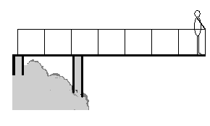
- On holiday in New Zealand, Shawn (mass 74.5 kg) is standing 0.300 m from the end of a 5.60 m viewing platform. The 680 kg platform is supported by two supports, one at the start of the platform and one 1.40 m from the start as shown. Determine the force on each support. (3 marks)

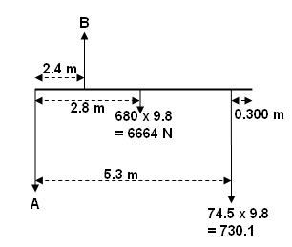
take moments about A
ΣCM = ΣACM
(6664 x 2.8) + (730.1 x 5.3) = B x 2.4 [1 mark]
18659.2 + 3869.53 = 2.4B
22528.73 = 2.4B
B = 9387 N

F up = F down
9387 = A + 6664 + 730.1 [1 mark]
9387 = A + 7394.1
A = 1993 N

A = 1.99 x 10³ N up
B = 9.39 x 10³ N down

[1 mark]
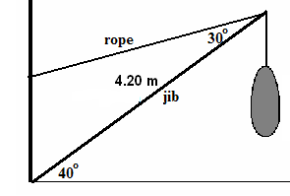
- A large crane is being used to lift a fishing net full of fish onto a ship. At the instance shown, the jib forms an angle of 40.0⁰ to the horizontal and the rope an angle of 30.0⁰ to the jib as shown. The jib is 4.20 m long and has a mass of 40.0 kg. The net with the fish has a mass of 1.90 x 10³ kg. Draw a diagram then calculate the tension in the rope. (4 marks)
NOTE: Mass of rope is negligible compared to jib and fish.

[1 mark]
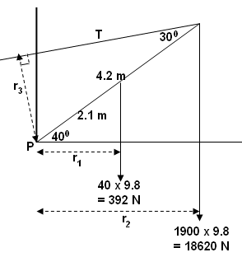
take moments about P
ΣCM = ΣACM
(392 x 1.6087) + (18620 x 3.2174) = T x 2.1 [1 mark]
630.61 + 59908 = 2.1T
60538 = 2.1T
T = 28828

T = 2.88 x 10⁴ N [1 mark]

r₁ = 2.1 cos 40 = 1.6087 m
r₂ = 4.2 cos 40 = 3.2174 m
r₃ = 4.2 sin 30 = 2.100 m
[1 mark]

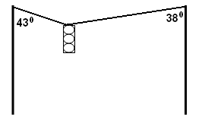
- A traffic light of mass 9.00 kg is suspended in the centre between two poles. One wire makes an angle of 43.0⁰ with the pole and the other 38.0⁰ as shown in the diagram below.
Find the tension in each wire.

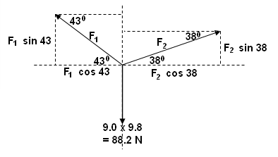

Horizontal components:

F₁ cos 43 = F₂ cos 38
0.7314F₁ = 0.7880F₂
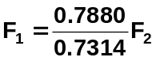
F₁ = 1.0774F₂

Vertical components:

up (F₁ sin 43) + (F₂ sin 38)
down 88.2 N

(F₁ sin 43) + (F₂ sin 38) = 88.2
0.682F₁ + 0.6157F₂ = 88.2

substitute F₁ = 1.0774F₂ into above equation then

0.682(1.0774F₂) + 0.615F₂ = 88.2
0.7348F₂ + 0.615F₂ = 88.2
1.3498F₂ = 88.2
F₂ = 65.34 N

substitute for F₂ = 65.34 in F₁ = 1.0774F₂

F₁ = 1.0774 x 65.34
= 70.4 N

F₁ = 70.4 N and F₂ = 65.3 N

